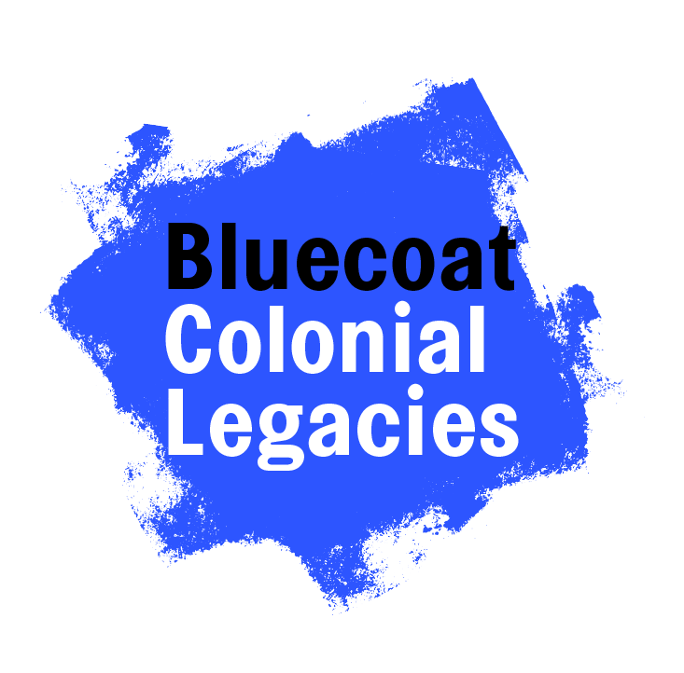
Accompanying info for The Bluecoat’s Colonial Legacies slides

Slide One
Bluecoat originally opened as a charity school in 1708 but has been an arts centre since 1906 when the school moved buildings. During 2021-2022, Bluecoat has facilitated an arts project with young people called Colonial Legacies; exploring the Bluecoat’s influence during the British Empire - what does ‘colonial’ mean? Colonial refers to colonisation - the process of settling among and establishing control over the indigenous people of an area. For this project this means: Britain went to various countries on the west coast of the continent of Africa and bought stolen people, they forcibly took them to the Americas (Caribbean, and places in North America like Virginia, and in South America like Brazil), and made them work on plantations - taking over the authority of land and law. We have explored how this act of colonisation has influenced this city through arts activities like; movement, drawing and poetry.

Slide Two
The Bluecoat was founded as a charity school in 1708 by Bryan Blundell and Reverend Robert Styth on behalf of the church. The original site became unfit for purpose so the current building was opened in 1717 for “the Christian teaching…”.

Slide Three
What connects the two pictures? (The Blue Coat School accounts ledger from 1717 and Bryan Blundell’s study of a merchant ship)

Like many 18th century Liverpool institutions, Bluecoat was built to a large extent with funds generated from the expanding port. Recent research suggests that at least 65% of regular subscriptions were derived directly from the trade in enslaved Africans or slavery-related commodities like sugar, tobacco and cotton.

Transatlantic slavery filtered through and shaped charity, education and culture. Merchants sailing from Old Dock, the revolutionary commercial wet dock nearby that opened in 1715, gave money to the charity school, but saw no contradiction between this and their work enslaving and selling Africans.

The Blue Coat School accounts book is open at a page showing annual subscriptions in 1717, many of them from Liverpool merchants who were, or would be, involved in the slave trade, such as Thomas Johnson, Richard Geldart (Gildart), Richard Norris and John Earle. Madam Clayton was the widow of tobacco and sugar merchant William Clayton. The original ledger is at Liverpool Record Office.

Sir Thomas Street is named after Sir Thomas Johnson (1664-1728-9). He was a mayor of Liverpool and one of the first people involved in the trade. He financed a slave ship in 1700 that went to the West coast of Africa and then to Barbados. He was also involved in the slave-produced tobacco trade in Virginia.
> see 3rd line of ledger

Tarleton provided the school with cotton for the uniforms of the school children - this was slave produced cotton. There is a street nearby Bluecoat named after him too.
> see 9th line of ledger

Slide Four
Bluetropolis Board Game Instructions

1. Roll the dice, person with the highest number goes first and the person on the left follows
2. Move the counter the correct number of spaces shown on the dice
3. If it lands on street name, this person was connected to the transatlantic slave trade and donated money to the Blue Coat School.
4. If it lands on a ? card you must answer the multiple choice question correctly to stay on your square, otherwise return (another player should read it out)
5. If it lands on an ! card you will either have to move one place backward or one place forward, these cards are designed to make you think about the legacies of colonialism, equality, and anti-racism in current times
6. The first person to reach back to the starting point wins

Hints
1. You will need a dice and counters
2. Educators should read through the cards first to prepare for the discussion that they may elicit

Slide Five
What was the merchant class? What was a philanthropist? The social benefits of these merchants all donating to the school, attending events there, having their portraits painted and hung together was like networking for their trading businesses. What is a colonial mindset - how could people enslave, indenture, and apprentice other people? What impact does it still have today? What do we think of these statues being torn down, artworks being recontextualised, education being ‘decolonised’?

Slide Six
By cross-referencing the Trans-Atlantic Slave Trade Database - available on the Slave Voyages website - with personal and local records, Blundell has been connected to ships that cumulatively engaged in fifteen slaving voyages, mainly to Bonny (in present-day Nigeria). These trafficked 4,719 enslaved Africans to the British West Indies - Barbados, Antigua, St Kitts, Nevis and Jamaica. Available statistics reveal that the total death count amongst those forced to board voyages fully or partially funded by Blundell was 801 people. The Trans-Atlantic Slave Trade Database also connects Blundell to a further 27 slave voyages, which transported 6,049 enslaved Africans, of which 1,556 died during the brutal ‘Middle Passage’ – however, it is likely that the majority, if not all, of these voyages were connected to his son, also named Bryan.

Blundell’s four sons and a grandson were involved in numerous other slave voyages until 1780, and further investigation of the Trans-Atlantic Slave Trade Database reveals that together the family had a stake in at least 111 voyages, transporting 29,679 enslaved Africans, of whom 5,634 died during the journey. This has been visualised in a map that was displayed in The Bluecoat’s Colonial Legacies exhibition (shown in the pictures on the slide). Altogether, the Blundell family donated at least £2,992 to the Blue Coat School, the equivalent today of around £646,000.

Slide Seven
Thousands came to Liverpool for work when the Old Dock was built in 1715. By 1800, the population had risen from 5,000 people to 78,000 people in under 100 years.

During the 18th century, Liverpool made about £300,000 a year from the slave trade. The rest of Britain's slave trading ports put together made about the same amount again. In the 1780s Liverpool-based vessels alone carried more than 300,000 Africans into slavery. By 1795 Liverpool controlled over 60 per cent of the British and over 40 per cent of the entire European slave trade.

The trade of African people and commodities produced by the enslaved occupied the port. Nearly all the main merchants and citizens of Liverpool, including many of the mayors, were connected to this industry. The connection to the pupils at The Blue Coat School is represented by this coat with unravelling tassels that was commissioned for The Bluecoat’s Colonial Legacies exhibition in 2022. The pupils would work long hours to spin the ‘slave-produced’ cotton supplied to the school by the merchant Tarleton.

Slide Eight
What do these words mean to you? What links can you find between 18th century school work, apprenticeship, indentureship, and slavery?

Here are some of our definitions to guide you

Colonial: relating to colonisation, where one nation conquers another and imposes its laws and customs, creating a franchise/colony of the country. For example, Britain built a navy that warred with indigenous people all over the world and conquered a quarter of the globe.
Mercantile: connected to the sea.
Transatlatic Triangle: refers to the of commodities exchanged for captured people in West Africa; the exchange of captured people for money or slave-produced raw materials in the Americas; and the trade of raw materials for money and commodities in Europe.
Enslaved person vs. slave: ‘enslaved person’ addresses the dehumanisation that African people have been subjected to through the Eurocentric gaze. The stolen and brutalised souls included artists and doctors, adults and children, before they were made into ‘slaves’. The adjective ‘enslaved’ describes their situation rather than naming them with the noun 'slave’. It gives dignity and respect.
Slave trade vs. slavery: the ‘slave trade’ refers to the brutal journey of enslaved people across the Atlantic, the ‘middle passage’ between West Africa and the Americas, whereas ‘slavery’ refers to the exploitation that happened on plantations.
Decolonise: there is no way to reverse the lasting legacies of colonialism but the act of decolonisation means addressing the enduring inequalities. Our programme is centred around decolonial practise because it educates the public about the true history of the Bluecoat building and creates space for anti-racist leaders and allies to be active in dismantling systems of oppression, as well as equitable opportunities for skills development.
Equity: actively addressing the uneven opportunities for people with protected characteristics (e.g. age, race, gender, disability). Unlike ‘equality', it doesn’t simply assume everyone has the same amount of privilege. Basically, the people who are on the outside of the running track at a race get to start a bit further forward.
Reparations: monetary, intellectual or other ways to compensate descendents of enslaved populations for the brutalisation that their ancestors faced during the transatlantic slave trade.

Everybody can have a role in recognising the legacies of our shared heritage, which one do you choose?

Slide Nine
The Bluecoat has chosen to address their challenging heritage through engaging local young people in a participatory arts project. Why do you think it is important to address these difficult histories? How can it impact an individual?

The young people on the Colonial Legacies project were empowered through the process of learning and sharing the heritage of their city:

“I loved seeing the amount of people who came to our exhibition, it made me personally feel happy that all the knowledge we put out is actually being embraced”

“This project has showed me a deeper insight into black history and knowing that other people feel the same as me”

Why do you think it is important to address these difficult histories? How can it impact a society? Our public were moved by the sharing of this hidden history too:

“beautiful to hear everyone sharing their work and perspectives on the world”

“So proud of every one of the artists and coordinators”

“Well inspired by last night and the colonial legacy project”

Slide Ten
After extensive research, the young people on the Bluecoat’s Colonial Legacies project co-curated an exhibition and hosted a series of public events:

Bluecoat Heritage Tour
Digitally explore the Bluecoat’s colonial heritage through this hyperfiction artwork.

Courtyard Poetry
Speaking out in Bluecoat’s outdoor spaces, featuring special guests! Part of Liverpool Against Racism festival.

The Mixed Race Experience
Naomi & Natalie Evans explore the mixed race experience. Part of WoWFEST22.

Malik Al Nasir
A keynote speech connecting Colonial Legacies and Looked After Children themes. Part of WoWFEST22.

Slide Eleven
Create an activist artwork based on the legacies of colonialism present in your life, this could be:

Living in a multicultural society, perhaps you’d like to draw your community
Education, perhaps you could design a talk about your culture/history/traditions that you would like your peers and teachers to engage with
Public spaces, could you create a paper sculpture of a monument commemorating the enslaved African people whose labour helped build this country
Ancestral/family legacies, could you illustrate a creative family tree
Racism, perhaps you could express your experiences through a poem
Colonial systems, perhaps you could write a short story on your ideal vision for a Liverpool against racism

Or maybe something else?

