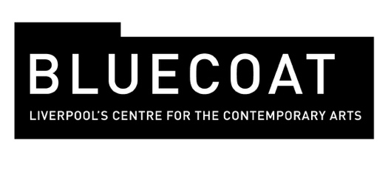
Release 7 February 2007

This city believes…
Bluecoat launches Liverpool Debates 2007

Bluecoat is launching Liverpool Debates 2007, a series of debates on hot topics for the city. Five debates will take place between April and September focusing on what really matters to Liverpool during its 800th anniversary year and as it approaches European Capital of Culture.
The topics, voted for by Liverpool Echo readers, are:

1 What happens when the handouts stop? Liverpool believes that its economic recovery is a mirage.
2 Bill Shankly, Harold Wilson and John Moores – true scousers? Liverpool believes that the city thrives because of outsiders.
3 Voter apathy? Liverpool believes that traditional politics has failed.
4 North West solidarity or regional rivalry? Liverpool believes that it’s time for Liverpool and Manchester to join forces.
5 Integration or toleration?
Liverpool believes that multiculturalism has succeeded.

Liverpool Debates invites everyone to focus on what really matters to Liverpool at this time when its past is being celebrated and sense of its own culture scrutinised. How, for instance, can the city recognise its past while at the same time move forward into a new era that embraces change, without losing its bearings? This connection between Liverpool’s sense of history and its understanding of its future is at the core of these debates, plugging into some of the key questions about citizenship and identity currently taking place in the British media.

The debates take place at Liverpool Lighthouse in Anfield, Academy of St Francis of Assisi in Kensington, St George’s Hall and Parklands Learning Centre in Speke.

